LAB221 Assignment | Type: | Short Assignment
 | Code: | J2.S.P0126
 | LOC: | 10
 | Slot(s): | 1

Title Colors choose
Background Context
A radio button or option button is a graphical control element that allows the user to choose only one of a predefined set of options.
Radio buttons are arranged in groups of two or more and displayed on screen as, for example, a list of circular holes that can contain white space (for unselected) or a dot (for selected). Each radio button is normally accompanied by a label describing the choice that the radio button represents. The choices are mutually exclusive; when the user selects a radio button, any previously selected radio button in the same group becomes deselected (making it so only one can be selected). Selecting a radio button is done by clicking the mouse on the button, or the caption, or by using a keyboard shortcut.

Program Specifications

Design a program that allows users change color using radio button.

Function details:

Program has four radios button to choose color.

Expectation of User interface:

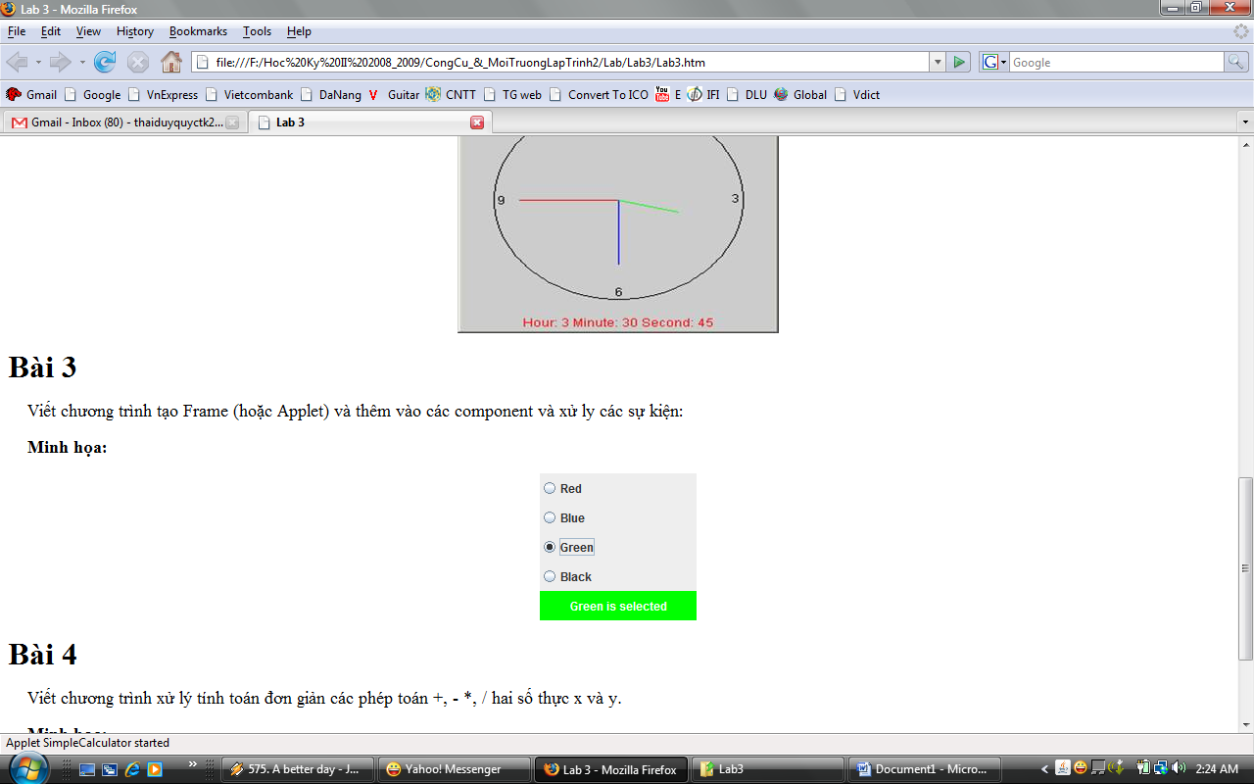

Guidelines

